Session 7

# An Expedition

## Permanent Storm

Dark clouds build over the road south of Nulvac. Issues can arise from that. In one place the road is flooding and must be forded.

A Nano is using a storm generator that looks like a large balloon to feed power into a large pink crystal.

*This crystal can be used to power the castle later if the party chooses to do so.*

## Electrical Sprites (optional)

Balls of energy that flit between the trees. One touch can stop a man’s heart. It is unclear if they are hostile, or curious and unaware of their own danger

If the PC’s get their attention they will begin coming toward them.

### Electrical Sprites (LV2)

Attack for 6

If hit with conductive weapons, deal 6 damage.

## Shadows and Mist

In the fog of night shadows appear, humanoid but amorphous. They stand in the tree line watching. They move strangely but are not threatening. They will eventually begin echoing words back, and then attempt to speak.

They will mainly hit words like “Danger” and “Lost” and “Please”

The people of Batos have a Nano who has been studying the shadows. He has seen another kind of shadow in the mist that seems to be a huge creature. He’s been working on a machine to allow people to cross into the plane these beings are on but needs many components. (Many of these can be found in the temple deep in the forest, he may also need info from someone in the dream sallow depending on how things are going).

### Nibovian Companion (on a 17+)

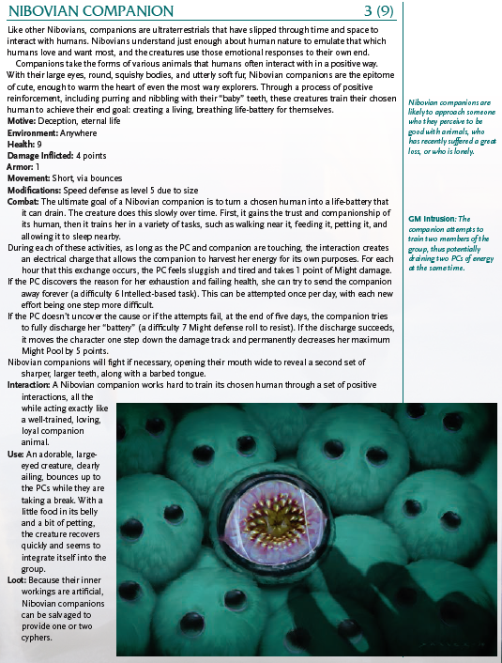

# The Creature in the Mist

With the notes returned the nano will get to work on a device that will let him commune with the shadow beings. If the players decide to go this route they will meet the silent and will be able to track the creature, which is a Travonis Ul

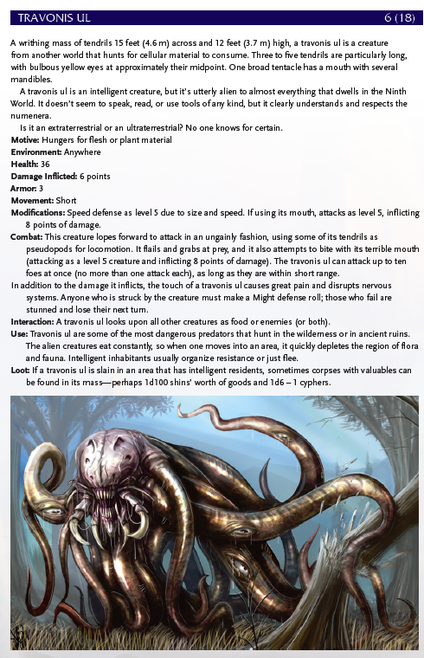

# Cultists

There are cultists in these woods wearing black and green robes. They are a radical sect of Hestans.

They have a town called Zeela that exists in the shadow of the great step pyramid.

Johann may be able to convince them that he wants to ascend which will allow access to the labyrinth.

# Labyrinth

## Prelude

The camp at the base of the pyramid is full of cultists. A level 5 guard to the pyramid prevents entry unless convinced to let them through.

## 1) Golems

There are 2 golems in this room, one with a red cryatal, one blue. They have a pattern etched on their back.

LV (4)

4 DMG

The crystals each open locks of corresponding colors

* A door with red circuit lines opens when the red crystal is placed in the lock.
  + The room behind that door goes to a heavy door and another blue lock that opens a door in the chamber behind the blue door
* A door with blue circuit lines opens when the blue crystal is placed in the lock.

## 2) Heavy Door

Lifting the door is a LV7. Otherwise figure it out.

* There is a blue door that leads to an antechamber
* The heavy door leads to another antechamber
* A doo opposite the heavy door leads to 3

## 3) Chasm

The two sides of the room are separated by a chasm the bottom of which can’t be seen. There are three lines of four lights floating in the air at floor level.

The pattern from the golem will show them the invisible path, or they can figure it out.

* There is a door to 2
* There is a door to 4 on the other side of the chasm

## 4) Shadows

A light source on one side of the room projects long shadows on the opposite wall. Along the top of the wall, 25 feet up, are three eyes, but one is visible. The long shadows obscure everything in them. The nearest shadow has the bottom half of a man sticking out. There are 3 obelisks.

The shadows destroy anything that enters them, but only the shadows of the obelisks.

The door to 5 is on the other side.

## 5) Chimera

A hulking creature surgically assembled from other beings. It has three heads of different species.

LV 5

## 6) Lock

Next to the door is a grid of buttons that light up when pressed. There are numbers around it.

Solving the picross puzzle opens the door.

## 7) Hestor

A man covered in stitches with different colored eyes and patchwork skin. He wears a robe and sits in a throne. Around the room are bones and surgical tools.

LV6 (18)

Damage 6

Armor 1

* Telekinesis
* Fly

Attacks with ranged force bolts

# Back in Town

# Crafting

## Lightning Staff

* Pink Charge Crystal
* 20 shins
* 3 XP
* A conductive rod of some kind
* An ark capacitor

*Range: Short*

*Damage: 4 (electric)*

# Places

## Batos

A town in the woods created by Culova

There is a “town hall” where the chief lives and history and legends are depicted on plaques hanging in the web. There is also a nano named Ukthu